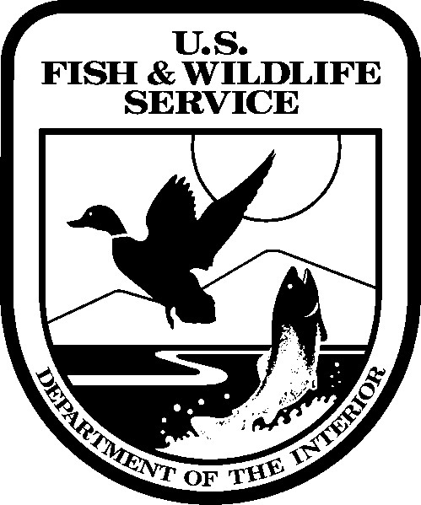 United States Department of the Interior

FISH AND WILDLIFE SERVICE

911 NE 11th Avenue

Portland, Oregon 97232-4181

In Reply Refer to:

FWS/R1/ABA-CGS

# RECONYX, Inc.

# 3828 Creekside Lane

**Holmen, WI**

**54636**

To Whom It May Concern:

The undersigned hereby claims exemption from sales or use tax on the purchase, lease, or rental of sales or taxable services from:

# RECONYX, Inc.

The United States and its unincorporated agencies and instrumentalities and any incorporated agency or instrumentality of the United States wholly owned by the United States or a corporation wholly owned by the United States…..**Department of the Interior Tax Exempt Number: 14-0001849**

This certificate shall continue in force until revoked and shall be considered a part of each order given to the above named seller or leaser. Use of this certificate does not exempt sales of taxable items to anyone other than the governmental unit indicated.

# Aisha Rickli-Rahman

Biological Science Technician