United States Postal Inspection Service
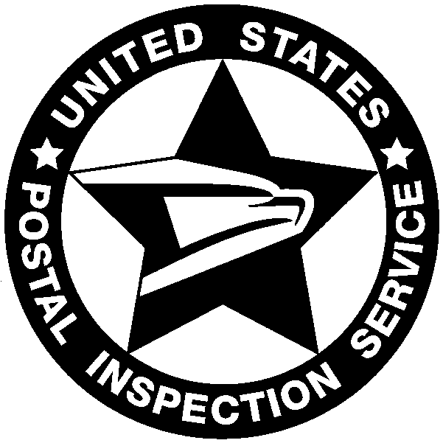

technical services unit
security group

EXEMPTION CERTIFICATE

(For use by the United States, States, Territories, or political subdivisions thereof, or the District of Columbia.)

Tax Exempt No. 41-0760000

Date: June 22, 2020

The undersigned hereby certifies that this office is authorized to execute this certificate and that the article or articles specified in the accompanying order or on the reverse side hereof, are purchased from:

RECONYX, Inc.
For the exclusive use of the U.S. Postal Inspection Service.

It is understood that the exemption from tax in the case of sales of articles under this exemption certificate to the United States, a State, etc., is limited to the sale of articles purchased for its exclusive use, and it is agreed that if articles purchased tax free under this exemption certificate are used otherwise or are sold to employees or others, such fact will be reported by me to the manufacturer of the article or articles covered by this certificate. It is also understood that the fraudulent use of this certificate to secure exemption will subject the undersigned and all guilty parties to a fine of not more than $10,000, or to imprisonment for not more than five years, or both, together with cost of prosecution.

Chris Spoerl
Senior Technical Surveillance Specialist
U.S. Postal Inspection Service
Philadelphia Division

